**Master Functional Document**

|  |  |
| --- | --- |
| **Application** | NGERP - Centra |
| **Service Bundle** | Master Management |
| **Service Request** | Group Credit Limit |

**Description :**

Group Credit Limit master is used to assign one credit limit for multiple business partners. While Creating a group credit limit a contract numer is created and it is assigned to multiple partners. If any one of the partner puts sales order above credit limit then every other partner assigned to that contract number will get credit limit error if they puts sales order.

**Workflow Process :**

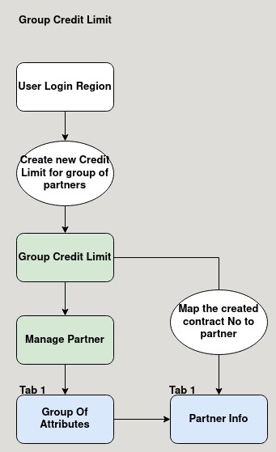

**Business Rules :**

* User should login as region to create a credit limit group.
* Create a contract number with the credit limit.
* Contract number can be mapped with AR trade partner in the partner info tab.
* Contract number can be mapped with multiple AR trade partner.
* When any one partner sales order is above credit limit, the credit limit error will show for all other partner.